**TASK-2**

* **(** [**Hello World Docker Image**](https://hub.docker.com/_/hello-world) **) Run Hello World Docker Image Locally.**

STEP 1: - Install requirements.txt file with command < pip install -r requirements.txt >

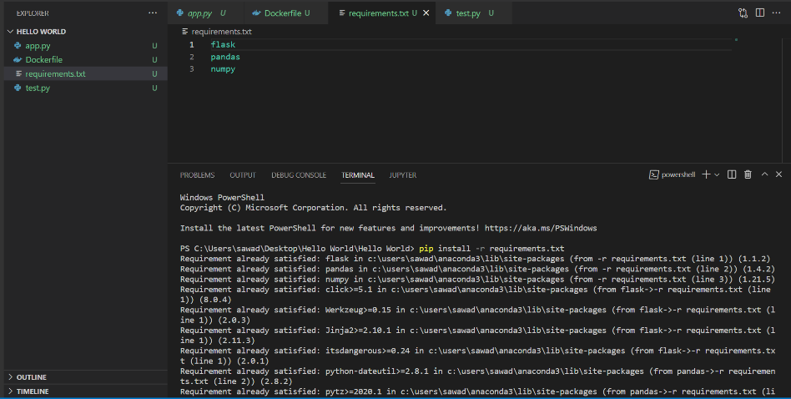

STEP 2: - Run python app.py file with command < python app.py >

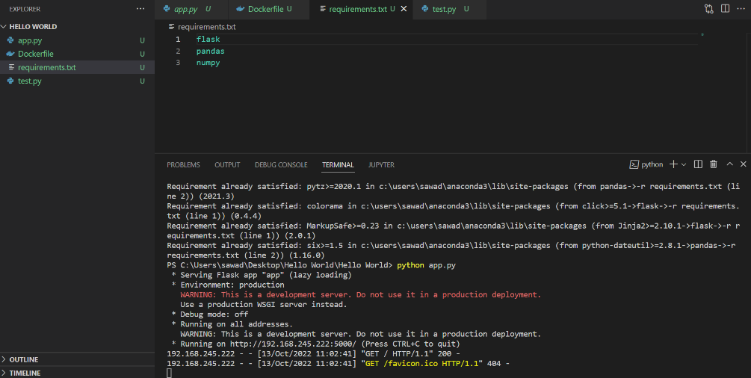

STEP 3: - Click on output URL and open in new tab just like following image.

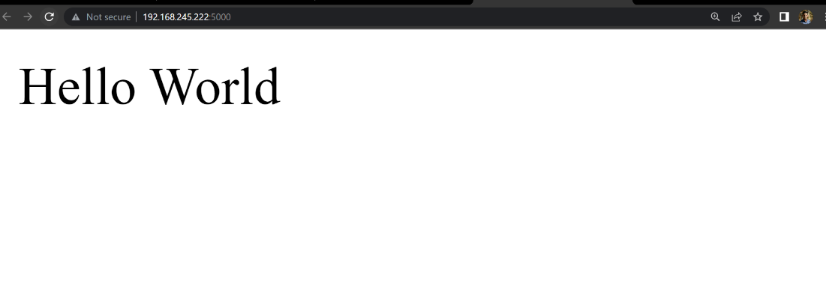

STEP 4: - Download welcome app with command < docker buildm -t welcome-app . >



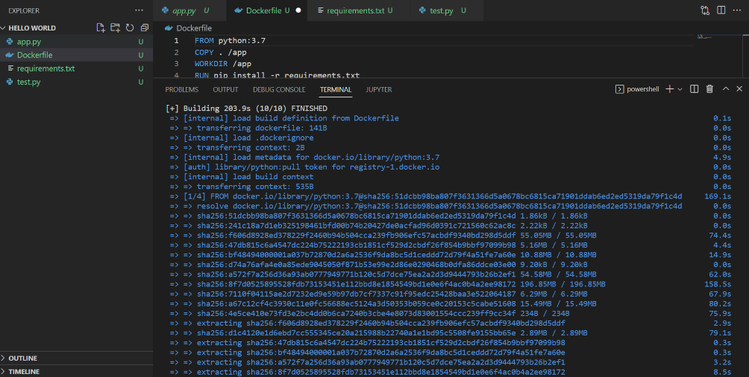

STEP 4: - **Check docker image with command < docker images >**

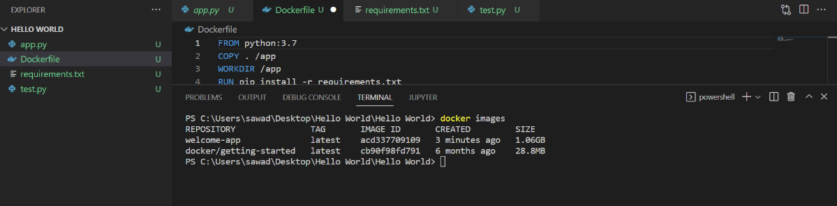

STEP 5: - **Check docker images in docker desktop app**

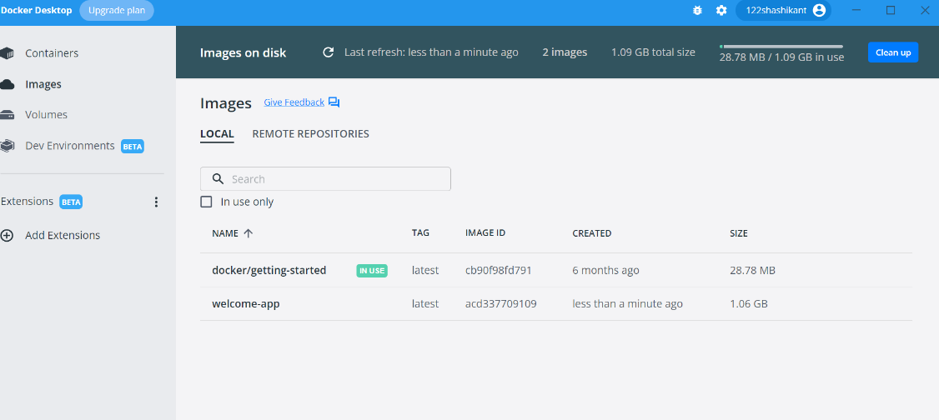

STEP 6: - Run docker container in locally with command < docker run -d -p 5000:5000 welcome-app

First 5000 is assigned port number

Second 5000 is container port number

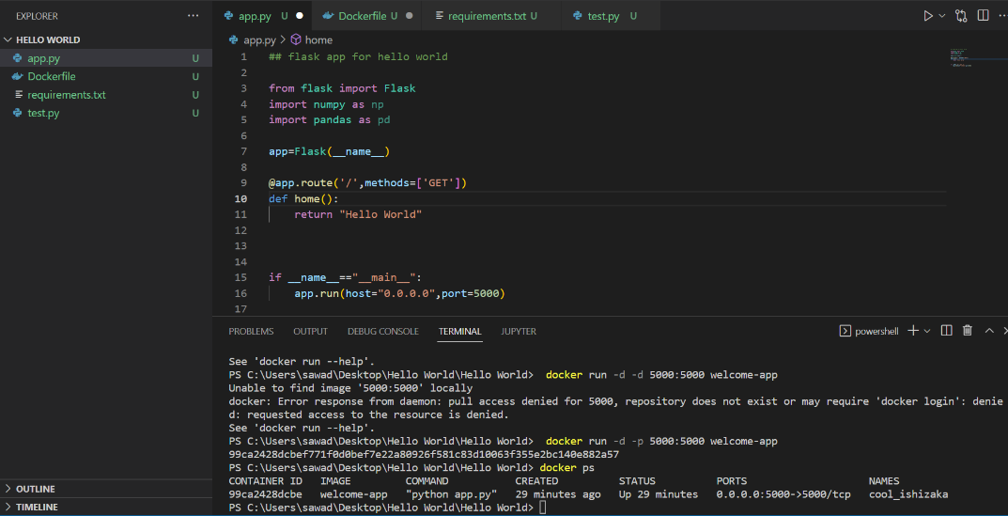

STEP 7: - Run in new tab with local host id with assigned port number after like 127.0.0.1:5000

